Institute for Research in Schools
Worksheet KS5.1 - Answers
The graphs below show the daily cases and death rates from Covid-19 in the US from March – July 2020.
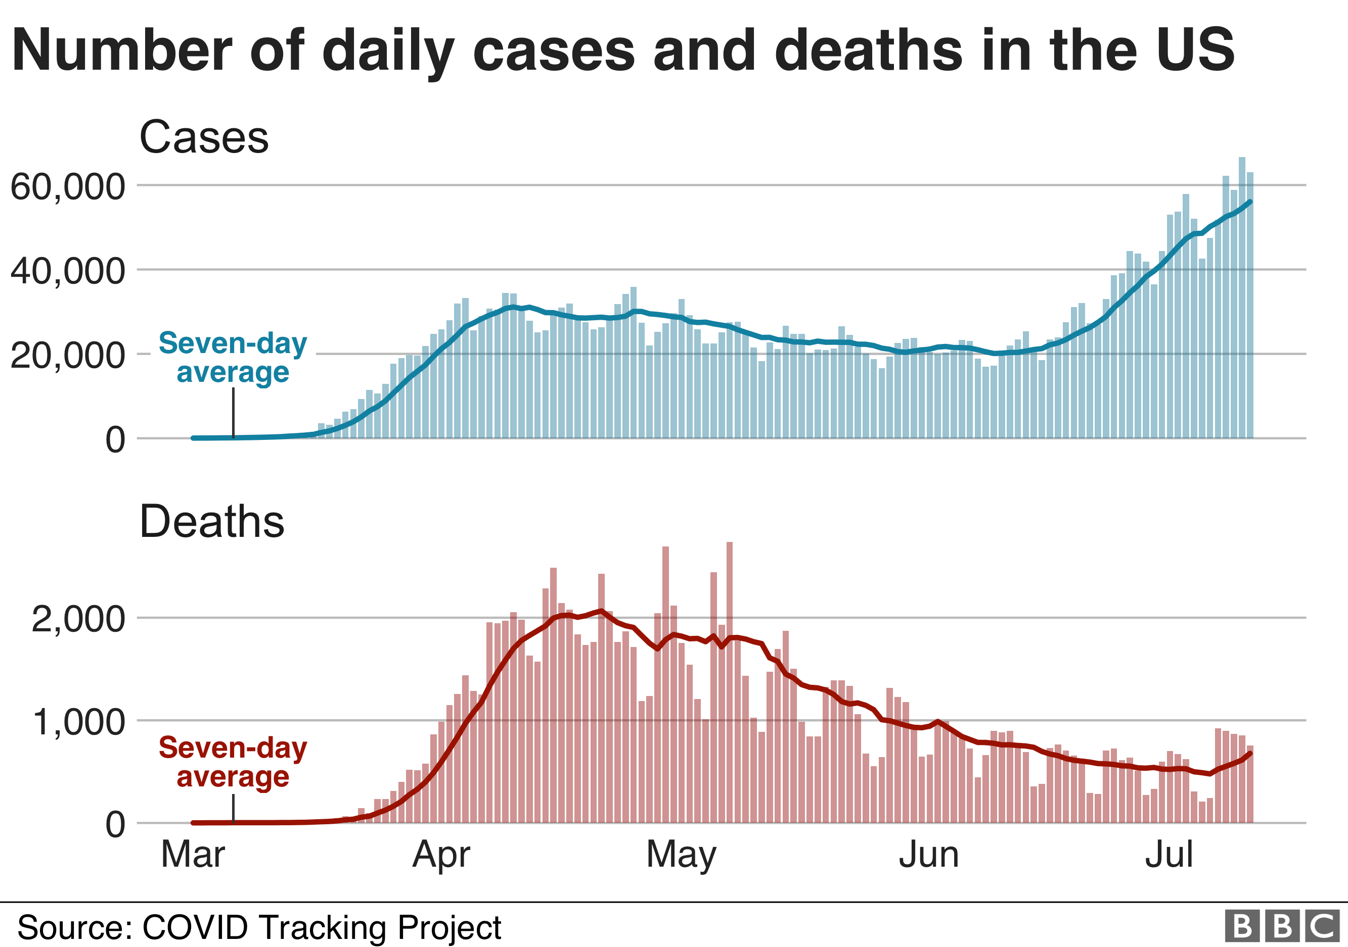
- Why is the seven-day average marked on the graphs? What are the reasons for the variations in the figures?
The seven-day average is marked on the graphs to smooth out the day-to-day variations in numbers so that trend can be seen. It is possible to see on both graphs that the cases and deaths reported dip each weekend.
- What was the death rate per 1000 Covid-19 cases in the US on 1st April? What assumptions have you made?

- Can you make a prediction about the number of deaths at the end of July? Give a reason for your answer.

- What problems could there be with this data? What would be useful for you to know to have a clearer picture of the impact of this disease?
- Most people who contract COVID-19 do not need to go to hospital. Hospitalisation rate is the proportion of people who need to be admitted for hospital treatment for a disease.
If the hospitalisation rate for COVID-19 was 5:100, how many people would be admitted to hospital if:
- 1000 people were infected?

- 20, 000 people were infected?

- Assuming an average hospital stay for COVID-19 is 21 days, approximately how many hospital beds were needed in the US during the first three weeks of April 2020? (Assume everyone admitted on day 1 is still in hospital on day 21)
- There are approximately 140,000 hospital beds in the UK. Assuming approximately one quarter can be repurposed to accommodate COVID-19 patients:
- How many hospital beds are Available to COVID-19 patients in the UK?

- How many of the population could be infected with COVID-19 before these beds were full? Assume the same hospitalisation rate as the US.

- How could information about hospitalisation rates be useful for an organisation such as Public Health England?

- What would be the impact if more people were infected with COVID-19 than the health service could treat using the staff and beds available? What would happen to other essential NHS services?

