Institute for Research in Schools
Worksheet KS5.1 - Answers
The graphs below show the daily cases and death rates from Covid-19 in the US from March – July 2020.
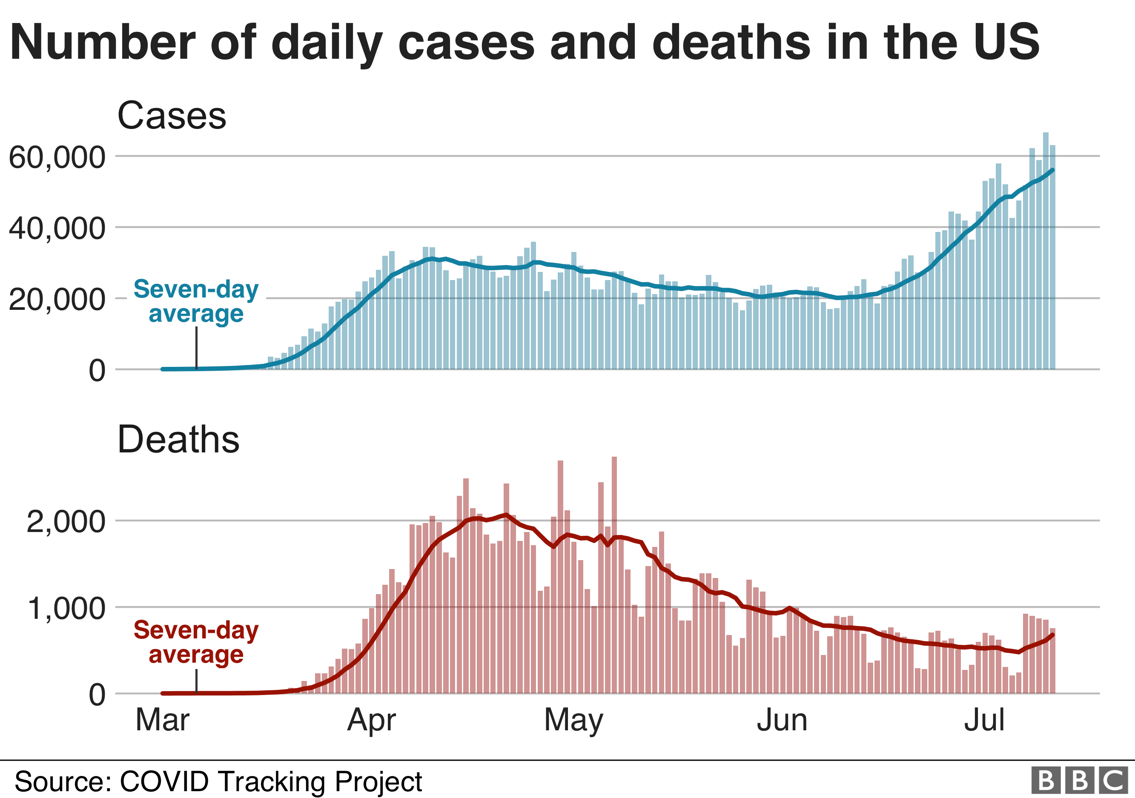
- Why is the seven-day average marked on the graphs? What are the reasons for the variations in the figures?
The seven-day average is marked on the graphs to smooth out the day-to-day variations in numbers so that trend can be seen. It is possible to see on both graphs that the cases and deaths reported dip each weekend.
- What was the death rate per 1000 Covid-19 cases in the US on 1st April? What assumptions have you made?
On the 1st of April there were Approximately 1000 deaths and on the same date there were approximately 25,000 cases of COVID-19 reported. This gives a death rate of 25 per 1000. The assumption that is made is that the death rate is correlated with the simultaneous number of infections. In fact, what we see is that an increase in death rates generally follows two or three weeks behind a peak in case numbers.
- Can you make a prediction about the number of deaths at the end of July? Give a reason for your answer.
There are approximately 55,000 cases of COVID-19 recorded in the US in mid July. If the same death rates apply, this would lead to approximately 25 x 55 = 1375 deaths

- What problems could there be with this data? What would be useful for you to know to have a clearer picture of the impact of this disease?
Calculating the death rates per case of COVID-19 depends on having an accurate picture of the total number of infections. It is likely that from March to May there were many fewer tests carried out than in June and July.
In order to get a clearer picture of the disease, it would be helpful to have more information on the number of tests carried out per 100,000 population. It would also be useful to know the percentage of positive tests out of all the tests carried out.
Only those feeling unwell are likely to be tested. This means that we may not get a clear picture of the spread of the disease, particularly if some individuals are less likely to get tested or are asymptomatic. It is helpful to have random sampling of the population to get a better picture of the infection rate that includes those who do not have symptoms.
- Most people who contract COVID-19 do not need to go to hospital. Hospitalisation rate is the proportion of people who need to be admitted for hospital treatment for a disease.
If the hospitalisation rate for COVID-19 was 5:100, how many people would be admitted to hospital if:
- 1000 people were infected?
If 1000 people were infected, and 5 in 100 needed to be hospitalised, 50 people would be admitted to hospital if a thousand were infected.

- 20, 000 people were infected?
If 20,000 people were infected and 5 in 100 needed to be hospitalised, 10000 people would be admitted to hospital if 20, 000 were infected

- Assuming an average hospital stay for COVID-19 is 21 days, approximately how many hospital beds were needed in the US during the first three weeks of April 2020? (Assume everyone admitted on day 1 is still in hospital on day 21)

To answer this question we must first look at the case data for the month of April. We can estimate that on each day of April approximately 30,000 people tested positive for COVID-19 each day.

30, 000 cases per day gives 1500 beds per day (x 21 days) = 31, 500 total beds.

- There are approximately 140,000 hospital beds in the UK. Assuming approximately one quarter can be repurposed to accommodate COVID-19 patients:
How many hospital beds are Available to COVID-19 patients in the UK?
140 000/4 = 35, 000 beds

How many of the population could be infected with COVID-19 before these beds were full? Assume the same hospitalisation rate as the US.
Hospitalisation rate is 5/100 or 1/20

35, 000 x 20 = 700, 000 over a 21 day period

This means that over a three week period, more than approximately
700, 000 infected in the UK would be higher than the number of hospital beds available.

The maximum rate number of new cases per day that could be accommodated would be 33, 333

- How could information about hospitalisation rates be useful for an organisation such as Public Health England?
It is important that everyone who needs a hospital bed to recover from COVID-19 can get one, or people are more likely to die from the disease. To make sure that enough hospital beds are available, Public Health England must use data such as the data in these graphs to calculate what resource will be required to deal with a public health emergency such as COVID-19.
If it becomes clear that the number of people infected is likely to exceed the ability of the health service to treat all these people, then measures must be put in place to try to reduce the number of people becoming infected.
In the initial stages of COVID-19, advice was given to the public which would help to reduce the rates of infection. This advice included thorough hand washing, and a requirement to isolate if people developed the symptoms of COVID-19.
Later in the pandemic, further restrictions included measures such as closing some shops and restaurants, closing schools to many pupils, and reducing social contact between individuals. In this way, it is possible to reduce the impact of a disease such as COVID-19.
- What would be the impact if more people were infected with COVID-19 than the health service could treat using the staff and beds available? What would happen to other essential NHS services?
If more people were infected than the health service could treat using the staff and beds available, additional staff and resources from less urgent NHS services would need to be recruited to look after them. In the event of an overwhelmed health service, it is therefore likely that other NHS services, such as routine vaccinations and monitoring, and treatment for other illnesses such as heart disease, cancer, stroke, and accidents could be delayed.
This would not only impact patients with COVID-19 but all our essential NHS services that we rely on to keep the population healthy. Therefore, it is critical to manage the numbers of people becoming infected with COVID-19, and to keep these numbers at a manageable level.

