Institute for Research in Schools
Worksheet KS4.1
The graphs below show the daily cases and death rates from Covid-19 in the US from March – July 2020.
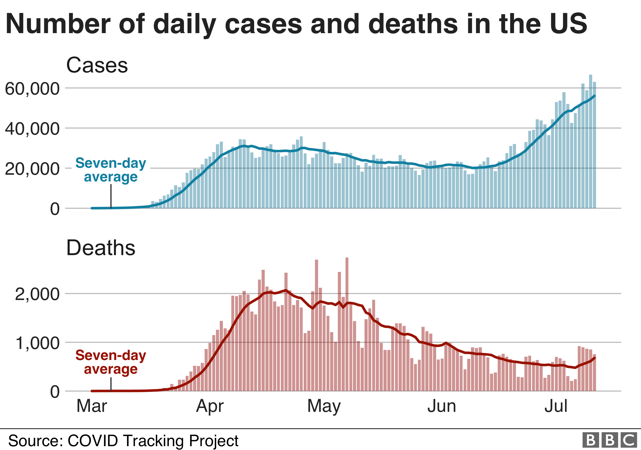
- Why is the seven-day average marked on the graphs? What are the reasons for the variations in the figures?
- What was the death rate per 1000 Covid-19 cases in the US on 1st April?
- Describe the trend you can see in the cases rate.
- Much more testing was carried out in July than in April. What problems could there be with this data?
- Most people who contract COVID-19 do not need to go to hospital. Hospitalisation rate is the proportion of people who need to be admitted for hospital treatment for a disease.
If the hospitalisation rate for COVID-19 was 5:100, how many people would be admitted to hospital if:
- 1000 people were infected?
- 20, 000 people were infected?

- How could information about hospitalisation rates be useful for an organisation such as Public Health England?

- What would be the impact if more people were infected with COVID-19 than the health service could treat using the staff and beds available? What would happen to other essential NHS services?

