Institute for Research in Schools
Worksheet KS4.1
The graphs below show the daily cases and death rates from Covid-19 in the US from March – July 2020.
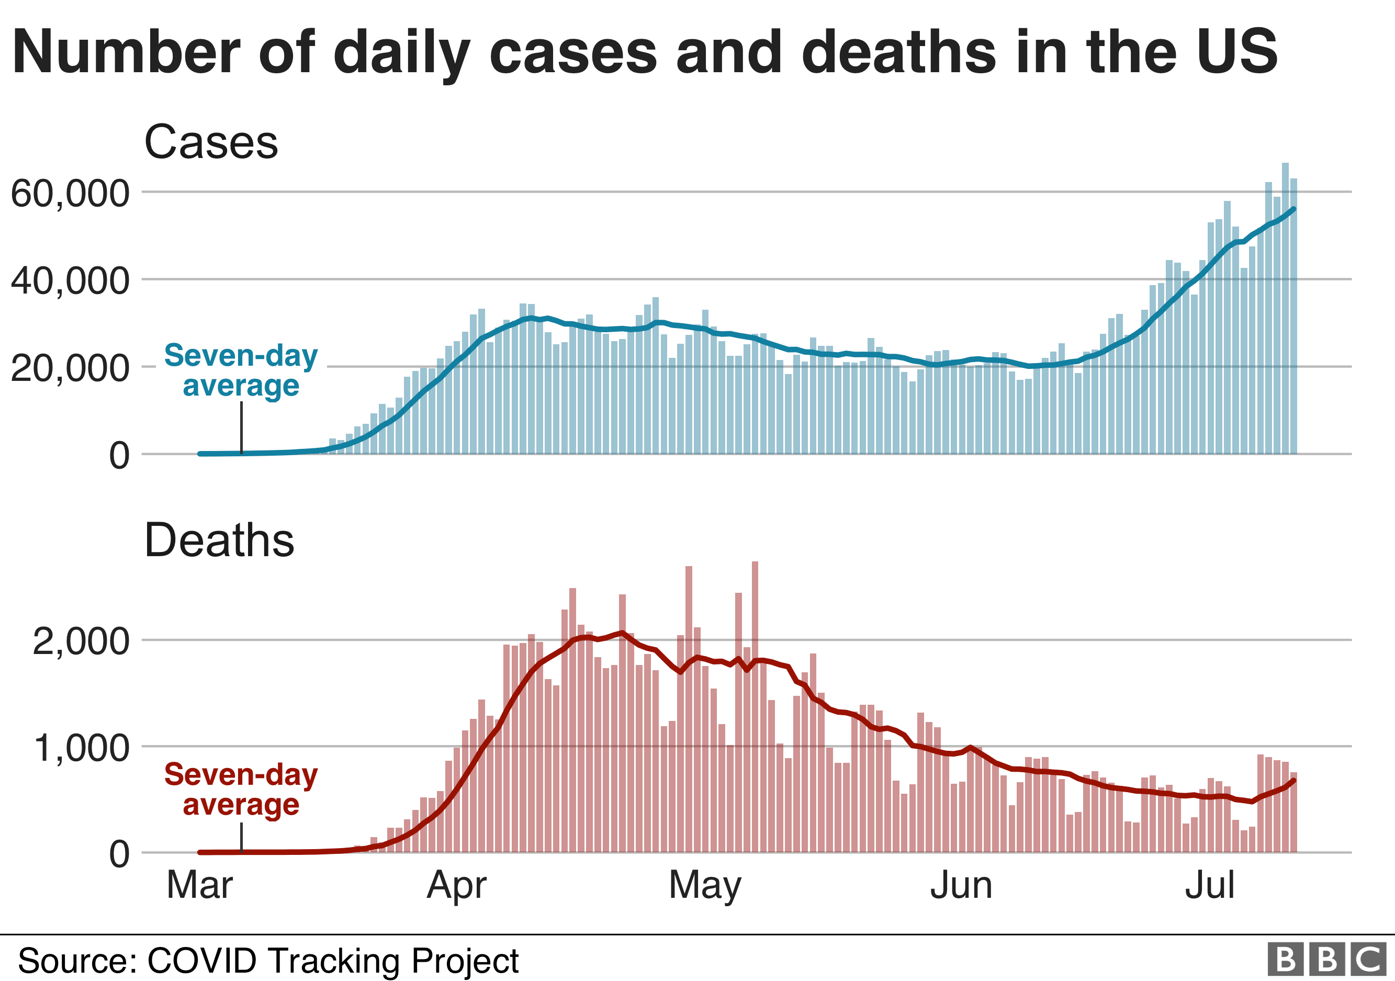
- Why is the seven-day average marked on the graphs? What are the reasons for the variations in the figures?
The seven-day average is marked on the graphs to smooth out the day-to-day variations in numbers so that trend can be seen. It is possible to see on both graphs that the cases and deaths reported dip each weekend.

- What was the death rate per 1000 Covid-19 cases in the US on 1st April?
On the 1st of April there were approximately 1000 deaths and on the same date there were approximately 25,000 cases of COVID-19 reported. This gives a death rate of 25 per 1000.

- Describe the trend you can see in the cases rate.
The cases in March are very low, and then rise during April to approximately 30, 000 cases per day. This case rate very slowly declines to approximately 20,000 in June, before rapidly rising to above 50, 000 cases by mid-July.
- Much more testing was carried out in July than in April. What problems could there be with this data?
If a lot more testing was done in July than April then a lot more positive cases might be picked up in July than in April. It is not possible from this data to know whether this is an increase in cases or an increase in testing (or both).

- Most people who contract COVID-19 do not need to go to hospital. Hospitalisation rate is the proportion of people who need to be admitted for hospital treatment for a disease.
If the hospitalisation rate for COVID-19 was 5:100, how many people would be admitted to hospital if:
- 1000 people were infected?
50 people

- 20, 000 people were infected?
1000 people

- How could information about hospitalisation rates be useful for an organisation such as Public Health England?
It is important that everyone who needs a hospital bed to recover from COVID-19 can get one, or people are more likely to die from the disease. To make sure that enough hospital beds are available, Public Health England must use data such as the data in these graphs to calculate what resource will be required to deal with a public health emergency such as COVID-19.
If it becomes clear that the number of people infected is likely to exceed the ability of the health service to treat all these people, then measures must be put in place to try to reduce the number of people becoming infected.
In the initial stages of COVID-19, advice was given to the public which would help to reduce the rates of infection. This advice included thorough hand washing, and a requirement to isolate if people developed the symptoms of COVID-19.
Later in the pandemic, further restrictions could include measures such as closing some shops and restaurants, closing schools to many pupils, and reducing social contact between individuals. In this way, it is possible to reduce the impact of a disease such as COVID-19.

- What would be the impact if more people were infected with COVID-19 than the health service could treat using the staff and beds available? What would happen to other essential NHS services?
If more people were infected than the health service could treat using the staff and beds available, additional staff and resources from less urgent NHS services would need to be recruited to look after them. In the event of an overwhelmed health service, it is therefore likely that other NHS services, such as routine vaccinations and monitoring, and treatment for other illnesses such as heart disease, cancer, stroke, and accidents could be delayed.
- This would not only impact patients with COVID-19 but all our essential NHS services that we rely on to keep the population healthy. Therefore, it is critical to manage the numbers of people becoming infected with COVID-19, and to keep these numbers at a manageable level.

